|  |
| --- |
|  |
| SUBMMITTED BY, |
|  |
| SWETHA R |
| au812921106036  swetharenga1705@gmail.com |
|  |
|  |
|  |

**FLOOD MONITORING**

AND EARLY WARNING SYSTEM

Introduction

A Flood Monitoring and Early Warning System (FMEWS) is a comprehensive infrastructure designed to detect, monitor, and provide timely alerts about potential or ongoing flood events. Its primary objective is to mitigate the impact of floods on communities, infrastructure, and the environment. This system employs a combination of sensors, data processing units, communication networks, and decision support systems to gather, analyze, and disseminate critical information related to water levels, weather conditions, and potential flood risks.

Block diagram

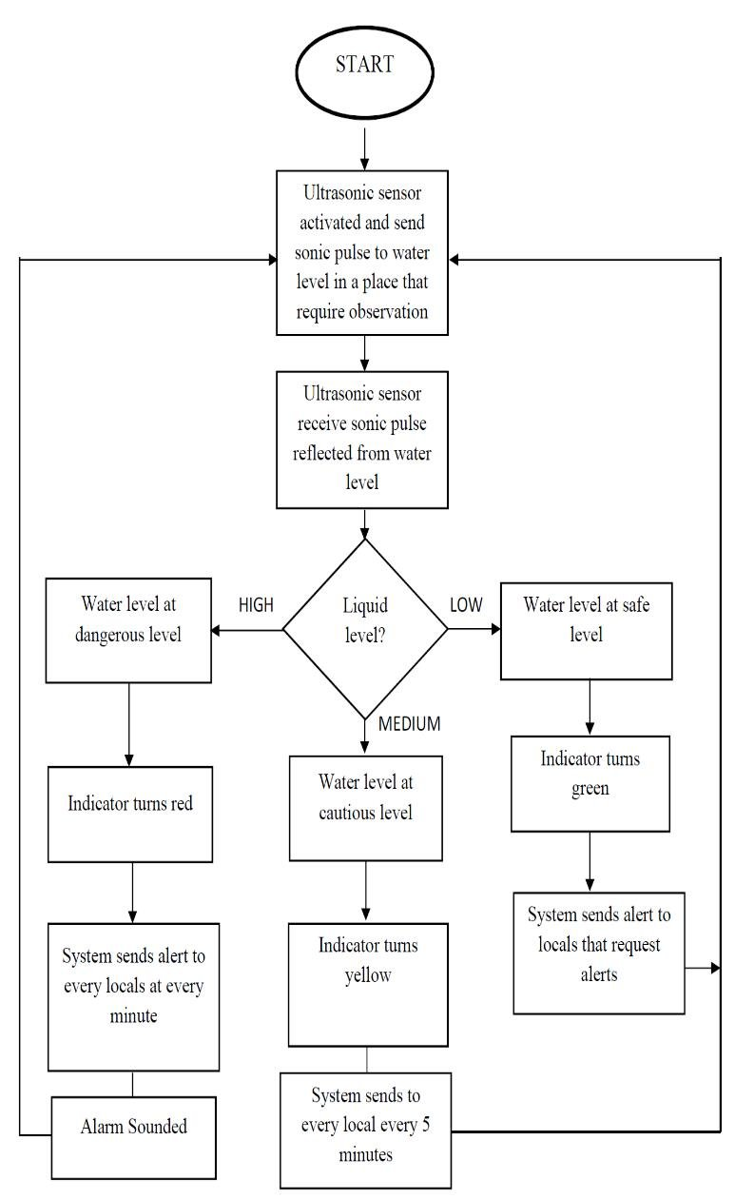

Explanation

**1. *Sensors*:** These are strategically placed devices that monitor various parameters such as water levels, rainfall intensity, and river flow rates. They provide real-time data essential for flood prediction and monitoring.

**2. *Data Processing and Analysis*:** Raw data from sensors is processed and analyzed to determine trends, anomalies, and potential flood risks. This component employs algorithms and models to interpret the data and make accurate flood predictions.

**3. *Communication Infrastructure*:** FMEWS relies on robust communication networks to transmit data between sensors, data processing units, and the central monitoring system. This can include wired or wireless networks, satellite communication, or a combination of these.

**4. *Central Monitoring and Decision Support System*:** This is the core component of the FMEWS. It integrates data from various sources, conducts real-time analysis, and utilizes historical information to make informed decisions about flood conditions. It can also provide recommendations for response actions.

**5. *User Interface*:** A user-friendly interface allows stakeholders, including government agencies, emergency responders, and the public, to access critical information. This can be in the form of dashboards, mobile applications, or web platforms displaying real-time data and alerts.

**6. *Alerting Mechanisms*:** The system is equipped with various alerting mechanisms to notify individuals and organizations at risk of impending floods. These alerts can be delivered via SMS, emails, sirens, or automated phone calls.

**7. *Community Engagement and Preparedness*:** FMEWS often includes public awareness campaigns and community engagement initiatives to educate people about flood risks and preparedness measures. This helps enhance the effectiveness of early warning systems.

**8. *Historical Data Storage and Analysis*:** Storing and analyzing historical data is crucial for improving flood forecasting models, understanding long-term trends, and refining response strategies.

**9. *Integration with Disaster Management Agencies*:** FMEWS often collaborates with local, regional, and national disaster management agencies to ensure coordinated response efforts in the event of a flood.

Program

include

LiquidCrystal lcd(2,3,4,5,6,7);

float t = 0;

float dist = 0;

void setup()

{

lcd.begin(16,2);

pinMode(18,OUTPUT); //trigger pin

pinMode(19,INPUT); //echo pin

pinMode(20,OUTPUT); //buzzer

lcd.setCursor(0,1);

lcd.print(" Water Level Detector");

delay(2000);

}

void loop()

{

lcd.clear();

digitalWrite(20,LOW);

digitalWrite(18,LOW);

delayMicroseconds(2);

digitalWrite(18,HIGH);

delayMicroseconds(10);

digitalWrite(18,LOW);

delayMicroseconds(2);

t=pulseIn(19,HIGH);

dist=t*340/20000;

lcd.clear();

lcd.setCursor(0,1);

lcd.print("Distance : ");

lcd.print(dist/100);

lcd.print(" m");

delay(1000);

if(dist<40)

{

digitalWrite(20,HIGH);

lcd.clear();

lcd.setCursor(0,1);

lcd.print("Water level is rising. Kindly evacuate");

delay(2000);

}

else

{

digitalWrite(20,LOW);

delay(2000);

}

}